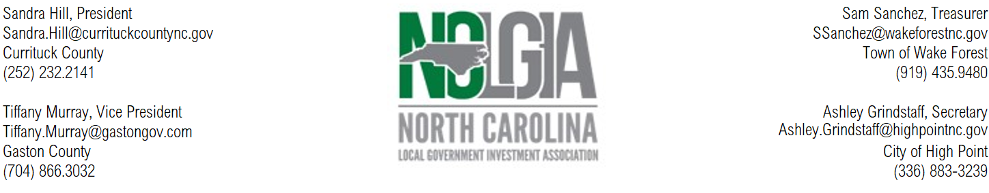

President Sandra Hill expressed appreciation for the following sponsors for supporting the Summer Conference at Wrightsville Beach. A round of applause was given to:
Recognition of Summer Conference sponsors:
- Premium Sponsor – North Carolina Capital Management Trust
- Platinum Sponsors – Civic Federal Credit Union, Public Trust Advisors
- Gold Sponsor – Wells Fargo, Multibank Securities, Inc, PFM Asset Management
- Silver Sponsors – UBS Financial Services, Davenport & Company, LLC, Bank of America
- Bronze Sponsors – Raymond James, Valley View Consulting, LLC, JP Morgan-Chase

All sponsors were excused before the regular business meeting was called.
The Business Meeting of the 2023 Summer Conference was called to order at 12:30 on July 19, 2023 by President Sandra Hill.
President Hill recognized the past presidents in attendance at the conference.
President Hill also recognized first time attendees by asking them to stand and introduce themselves.
Vice-President Tiffany Murray updated the membership on the location for the 2024 Summer Conference at the Embassy Suites in Wilmington, NC. She also gave the dates of the 2024 Winter Conference in Pinehurst and discussed contract discussions with Pinehurst for the 2025 and 2026 Winter Conferences.
Samantha Sanchez, treasurer, provided copy of treasurer’s report as of 6/30/2023. Ralph Staley made a motion, seconded by Mindy Taylor, to approve the treasurer’s report. The motion was unanimously approved.
Secretary Ashley Grindstaff provided copies of minutes of the Winter 2023 meeting. Cary Garner made a motion, seconded by Beth Kelly. The motion was unanimously approved.
New Business
Secretary Ashley Grindstaff discussed the proposed bylaws changes that were emailed to the membership in June 2023. She discussed the need for an additional board member to better serve our membership. Ralph Staley made the motion to approve the bylaw change, seconded by Roberta Johnson. The motion was unanimously approved.
President Hill announced that the board has nominated Seth Larson, Wake County to fill the Secretary position and Evans Ballard, Town of Mooresville to fill the Membership Coordinator position. President Hill proposed that the membership vote on the new officers as a whole to also include Tiffany Murray-President, Sam Sanchez-Vice-President, and Ashley Grindstaff-Treasurer. Mindy Taylor made the motion to approve the slate of officers, Cary Garner seconded the motion. The motional was unanimously approved.
President-elect Murray recognized Past-President Hill for her service to the organization.
Vice-President Murray asked the group if they had any new business to discuss.

Other Business
Attendees were reminded to complete CPE sign in forms for the morning and afternoon sessions. Attendees also were reminded about the NCCMT reception.
President Hill asked anyone that might be interested in serving as an officer to respond on the evaluation.
Respectfully submitted,
Ashley Grindstaff
NCLGIA Secretary

